## 4CS015 – Portfolio Task #4

**STUDENT NAME**: Alan Shah

**STUDENT NUMBER**: 239767

You will need to complete the workshop and then submit this Word file, complete with your answers, via Canvas, by the end of Semester (week 12).

For this assignment (workshop) you will show you how to navigate and create file systems from command prompt in both Windows (os) and Linux(os), also how to create a batch file to be executed in the Windows (os).

**NOTE: Please make sure you have written your command as well as the screenshot of the commands. Failure to do so will result in marks deduction.**

**Task 1 (Windows Command Line)**

1. Write a command to Create a directory "**test**"

Md test

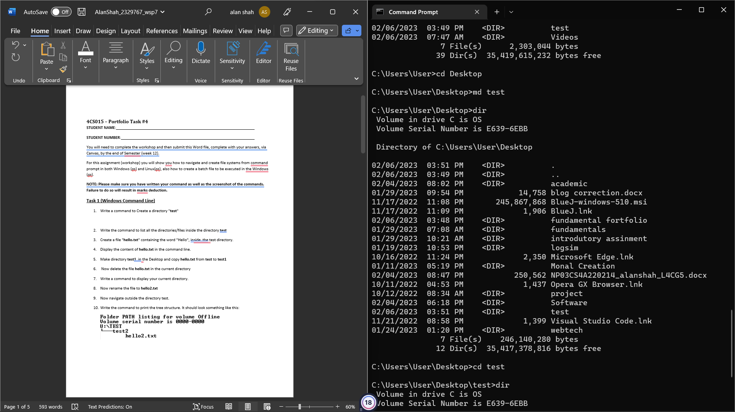

1. Write the command to list all the directories/files inside the directory **test**

dir

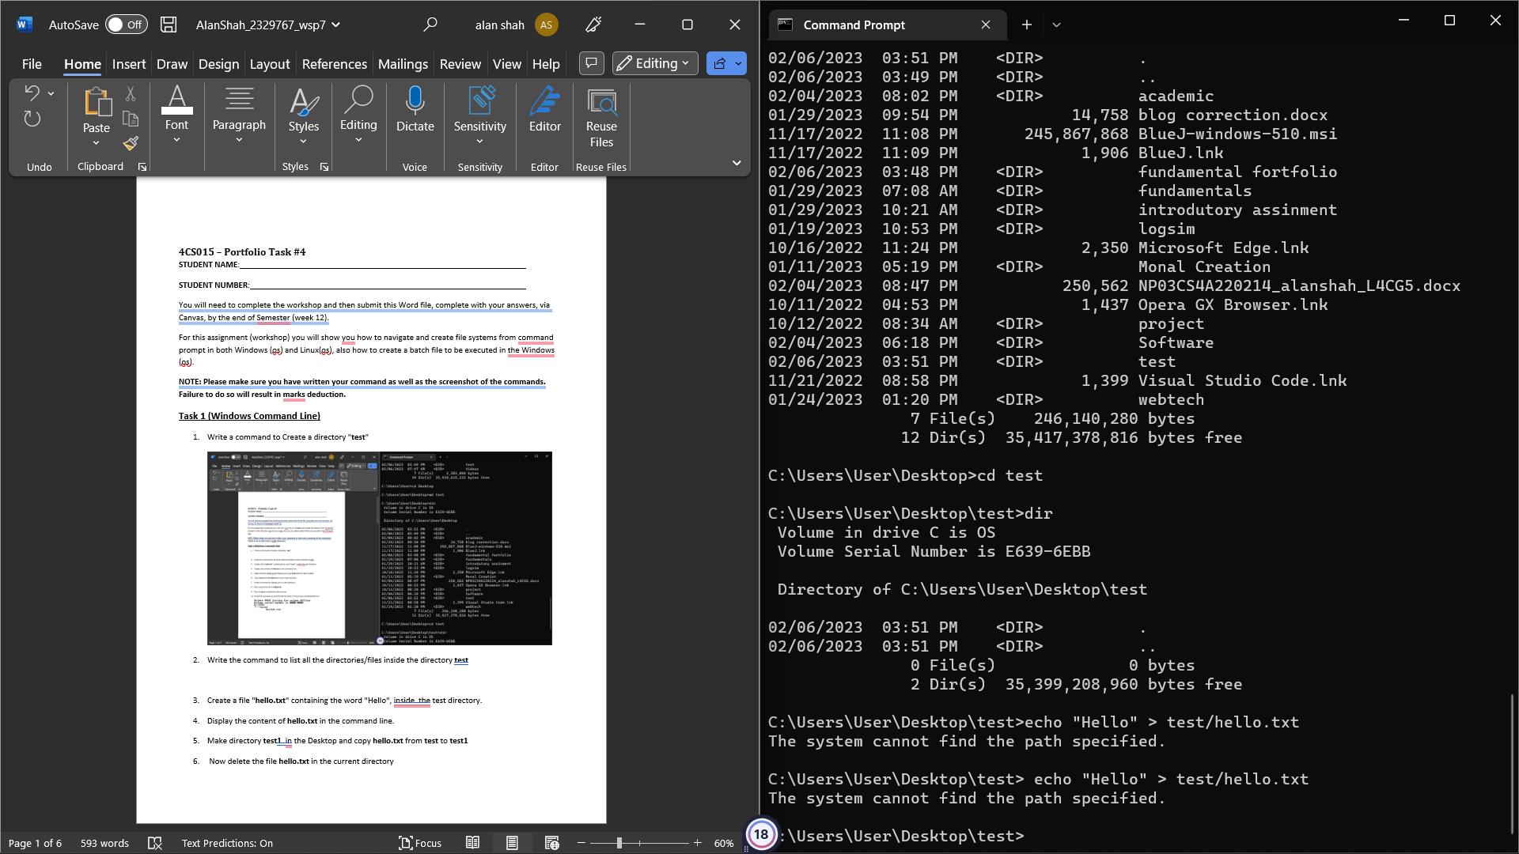

1. Create a file "**hello.txt**" containing the word "Hello", inside the test directory.

Type nul> hello.txt

Echo “Hello” > hello.txt

Type hello.txt

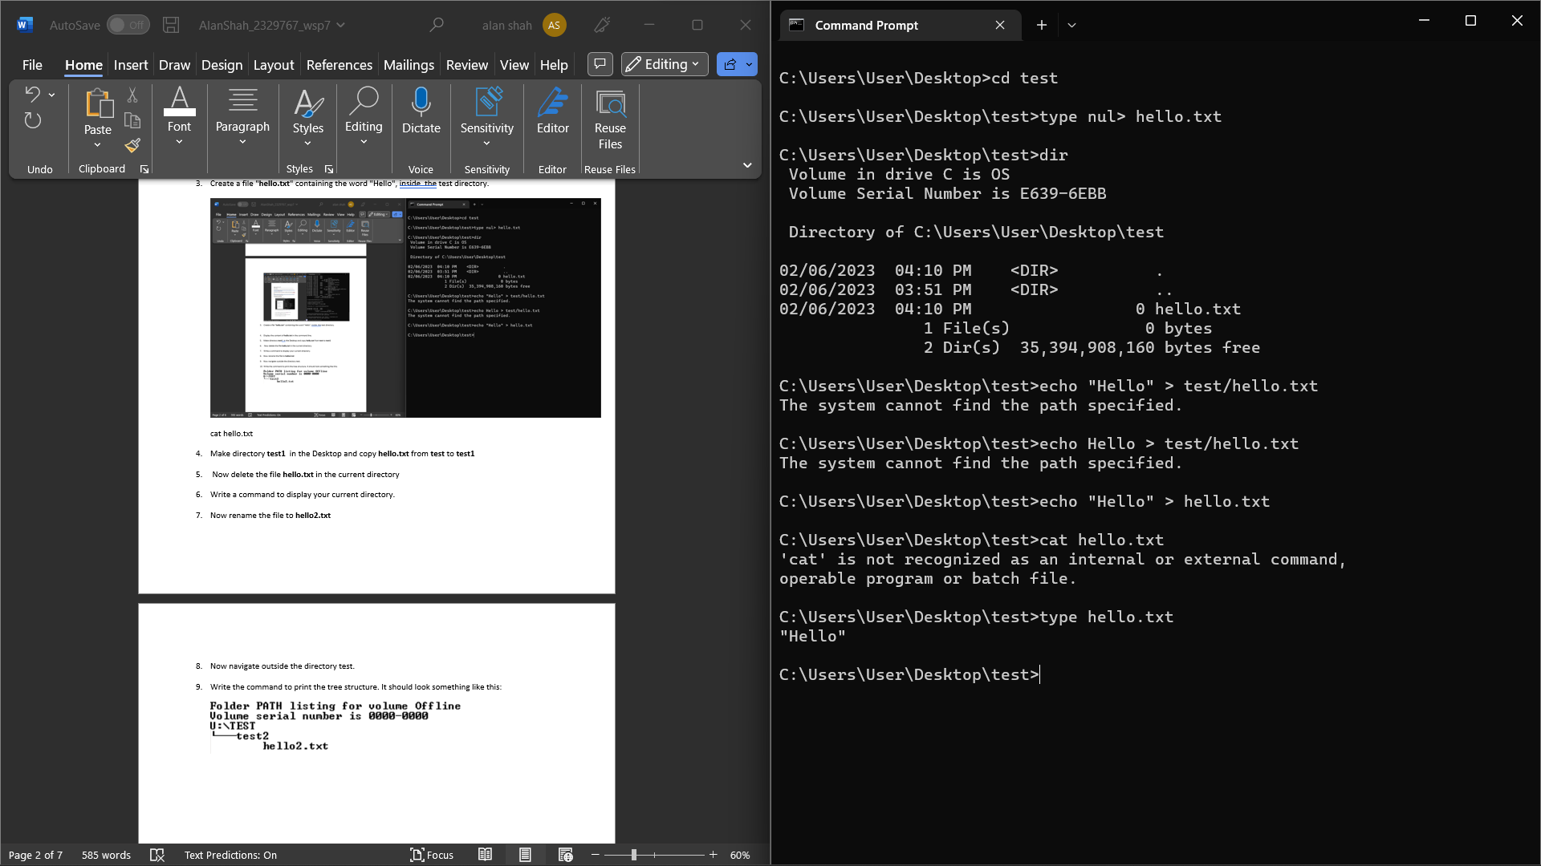

1. Make directory **test1** in the Desktop and copy **hello.txt** from **test** to **test1**

**DESKTOP** > md test1

**>** copy text\hello.txt “%userprofile\desktop\test1”

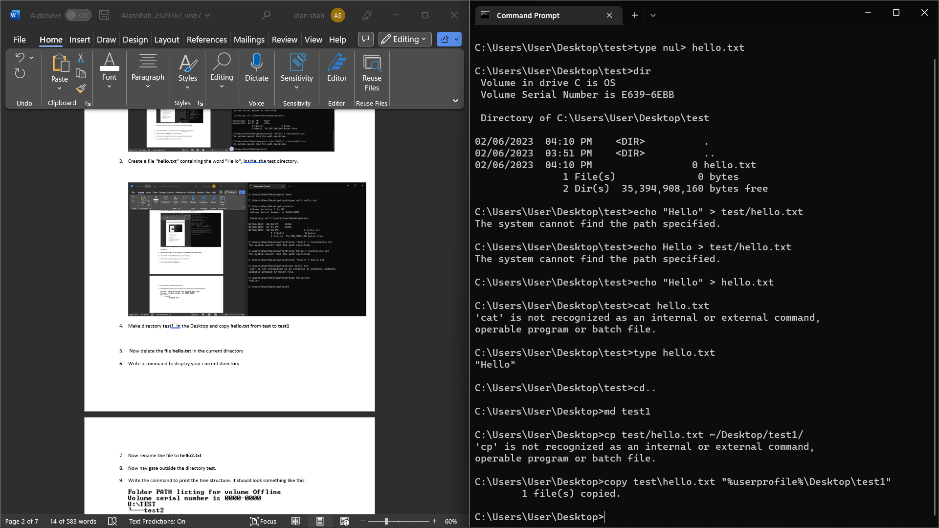

1. Now delete the file **hello.txt** in the current directory

Del hello.txt

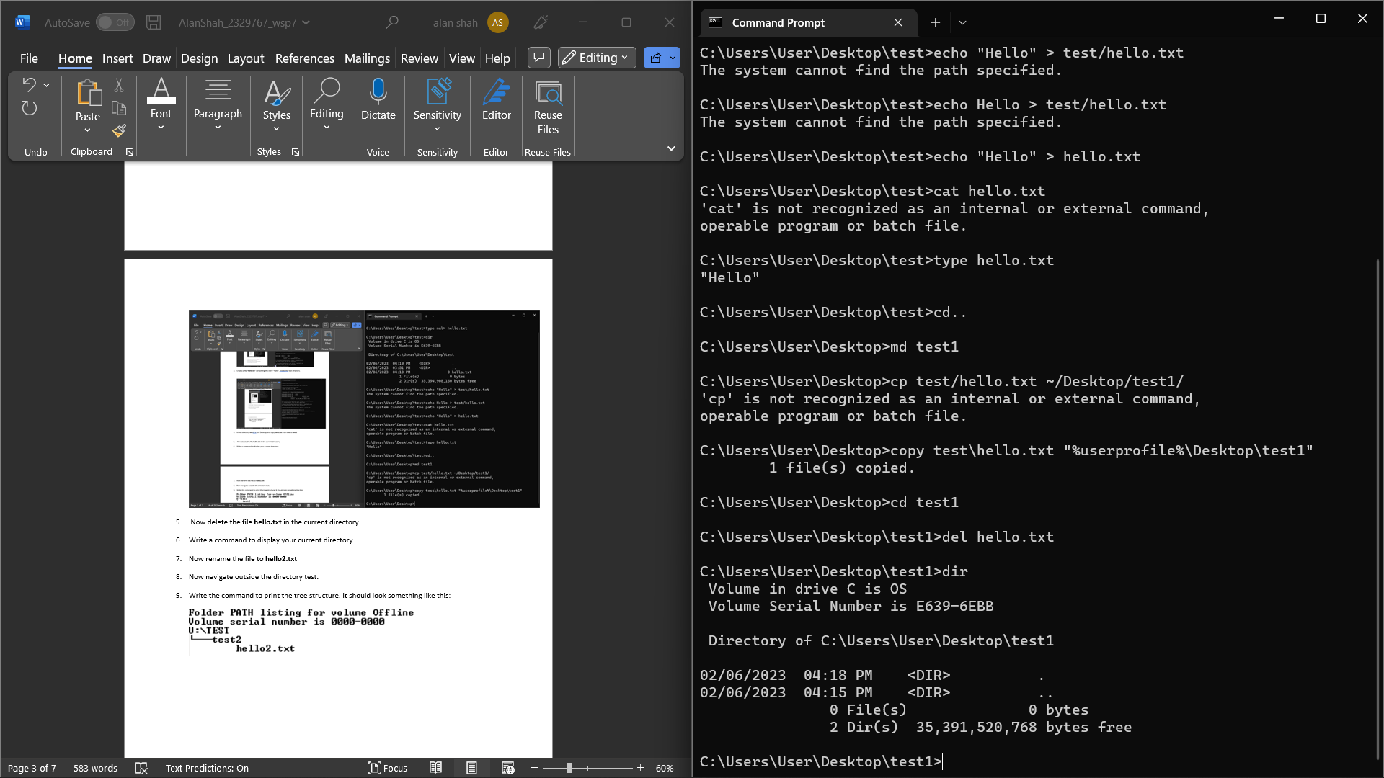

1. Write a command to display your current directory.

Echo %cd%

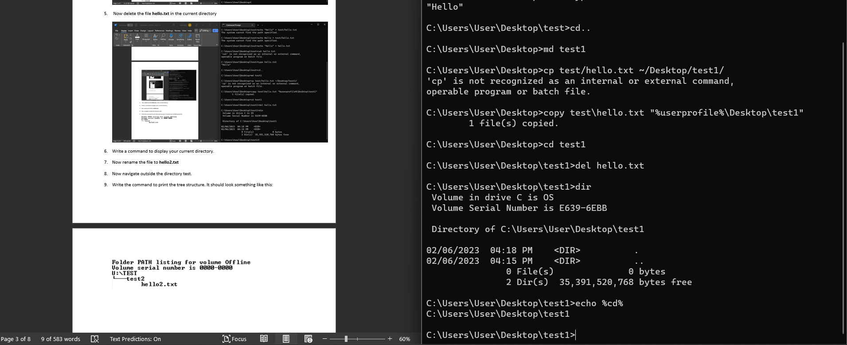

1. Now rename the file to **hello2.txt**

**Ren hello.txt hello2.txt**

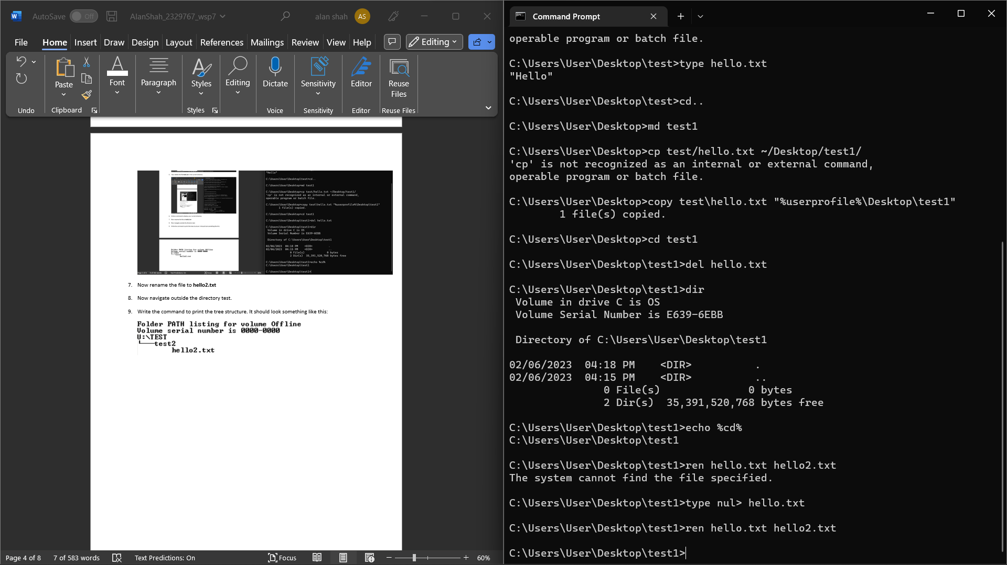

1. Now navigate outside the directory test.

Cd ..

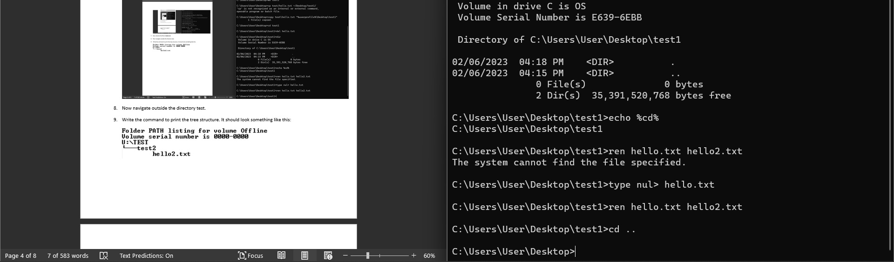

1. Write the command to print the tree structure. It should look something like this:

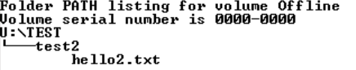

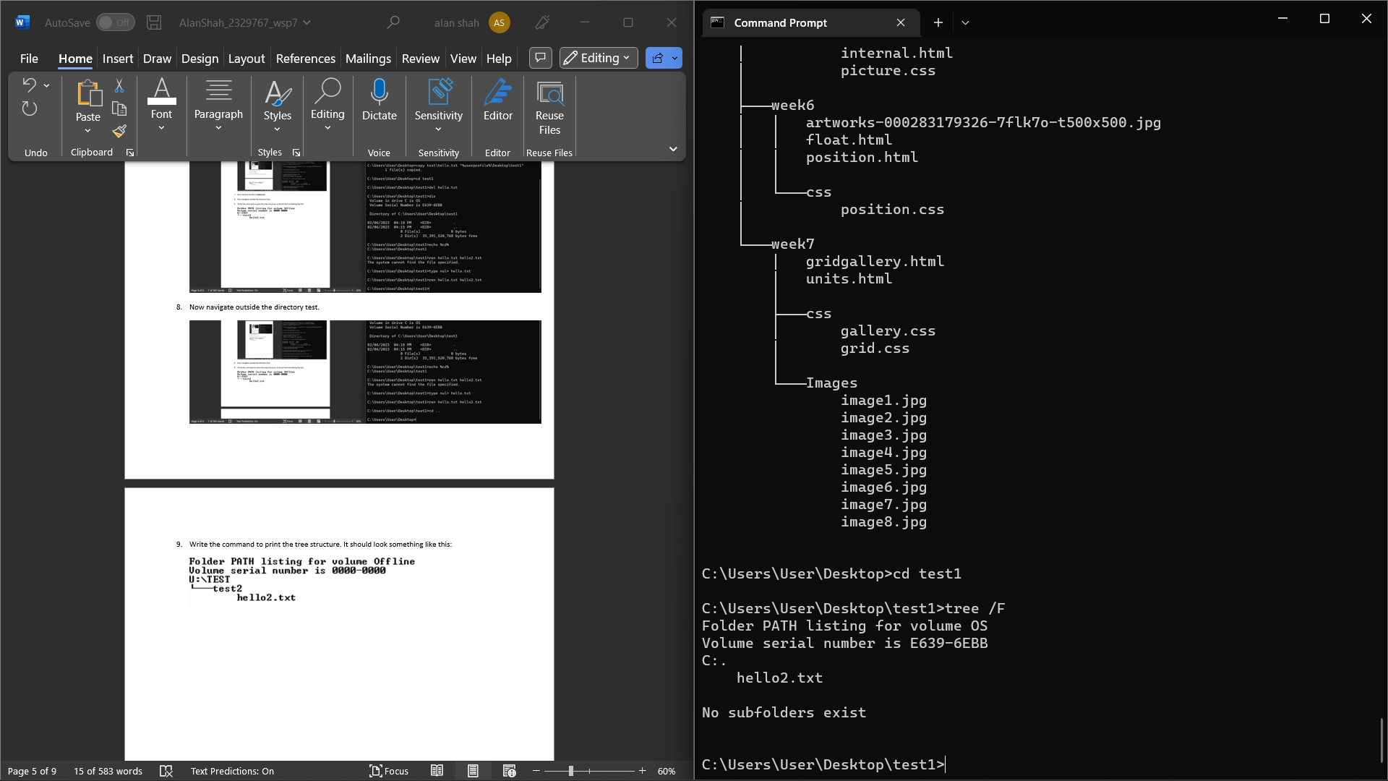

Tree/F

**Task 2**

Create the following directory structure and paste it after this picture. (15 marks):

**Note: MYMODULES must be inside <your_name> directory.**

**Make a directory with your name on the desktop and navigate to the directory before you display the following structure.**

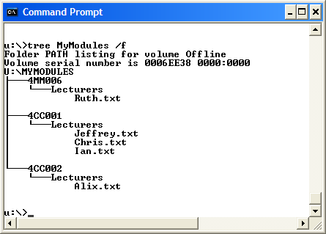

Md alan

Cd alan

Md MYMODULES

Cd MYMODULES

Md 4CS001 4CI018 4CS015

Cd 4CS001

Md lecturers

Cd lecturers

Type nul > ashish.txt

Type nul > phurba.txt

Type nul > pradeep.txt

Type nul > shiv.txt

Type nul > shiva.txt

Type nul > shujan.txt

Type nul > sunita.txt

Type nul > yogesh.txt

Cd 4CS001

Md lecturers

Cd lecturers

Type nul > ashish.txt

Type nul > phurba.txt

Type nul > pradeep.txt

Type nul > shiv.txt

Type nul > shiva.txt

Type nul > shujan.txt

Type nul > sunita.txt

Type nul > yogesh.txt

Cd ..

Cd 4CI018

Md lecturers

Cd lecturers

Type nul > dipesh.txt

Type nul > ishwor.txt

Type nul > manish.txt

Type nul > nerisha.txt

Type nul > phurba.txt

Type nul > raj.txt

Cd ..

Cd 4CS015

Md lecturers

Cd lecturers

Type nul >adarsha.txt

Type nul > bidhan.txt

Type nul > phurba.txt

Type nul > raj.txt

Type nul > uttam.txt

Type nul > yojana.txt

Cd ..

Tree/f

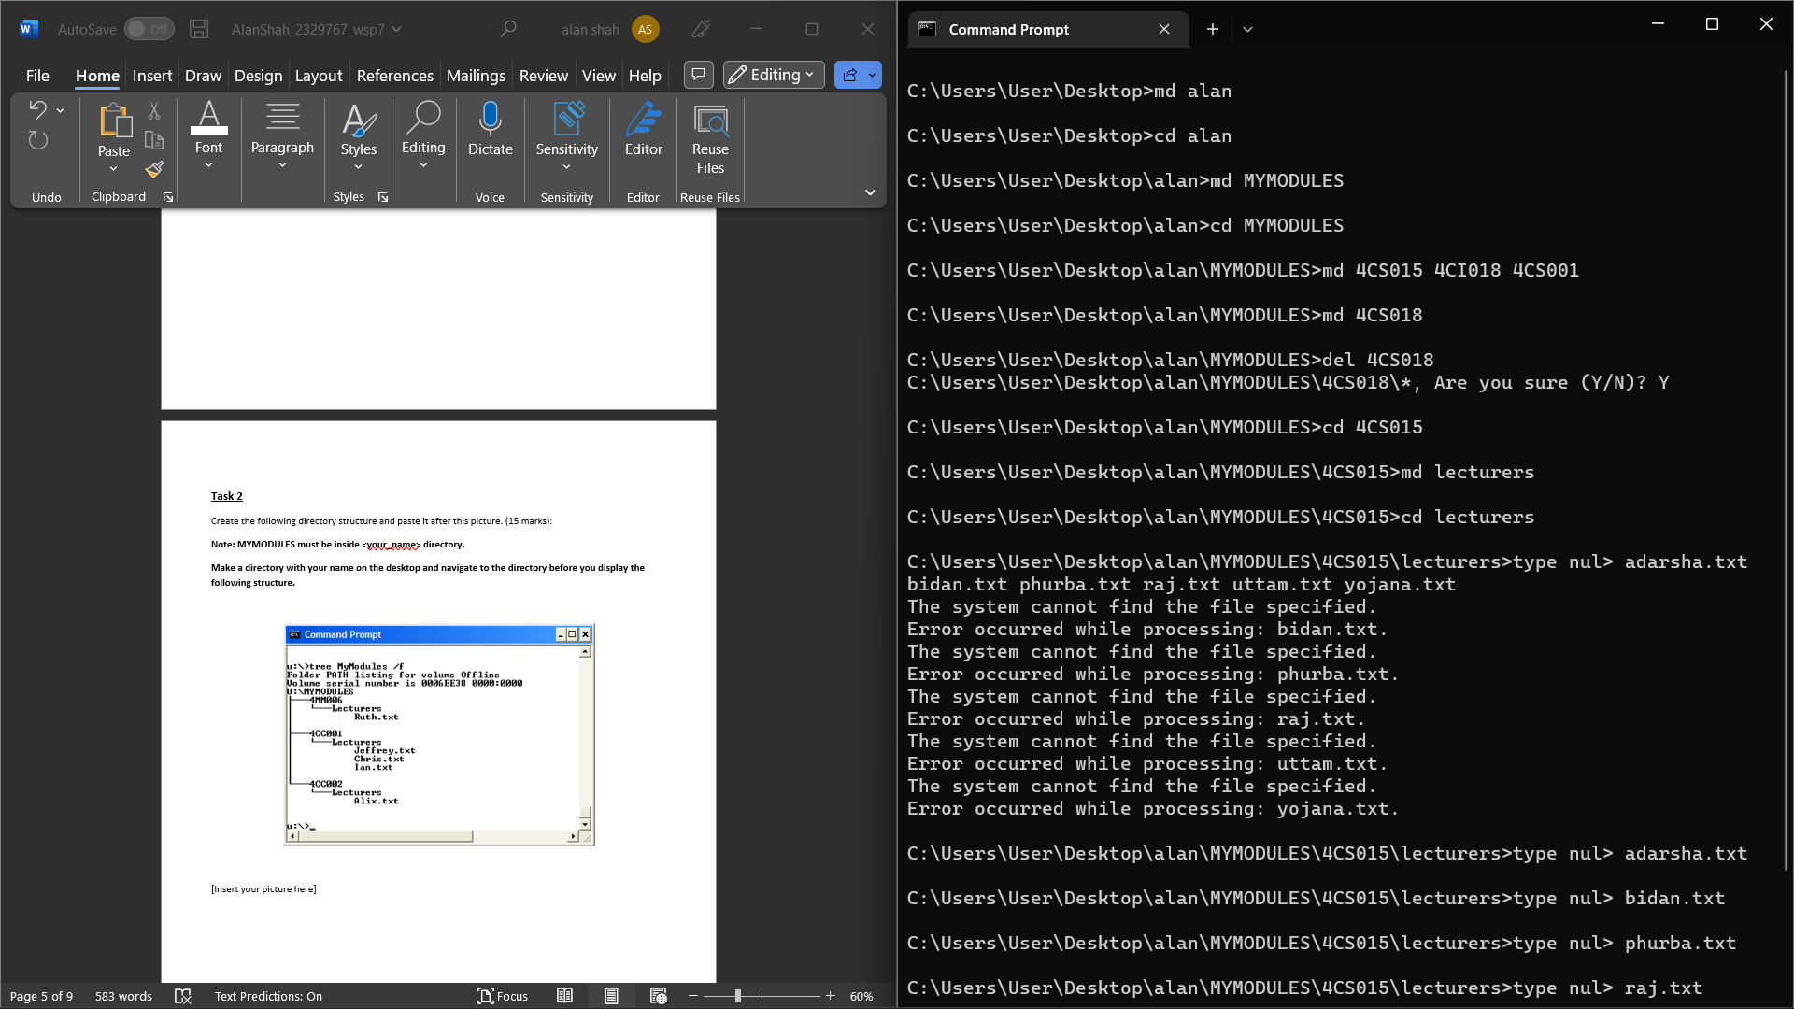

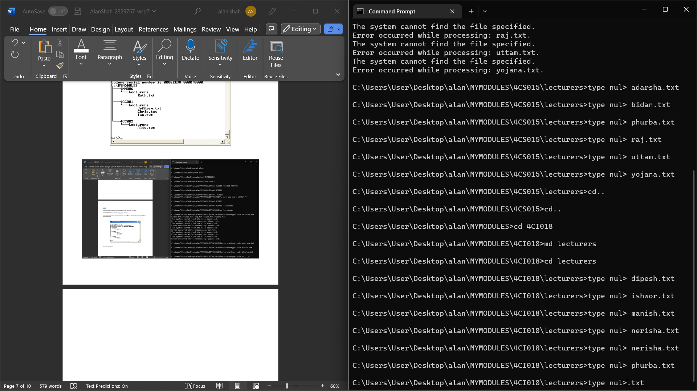

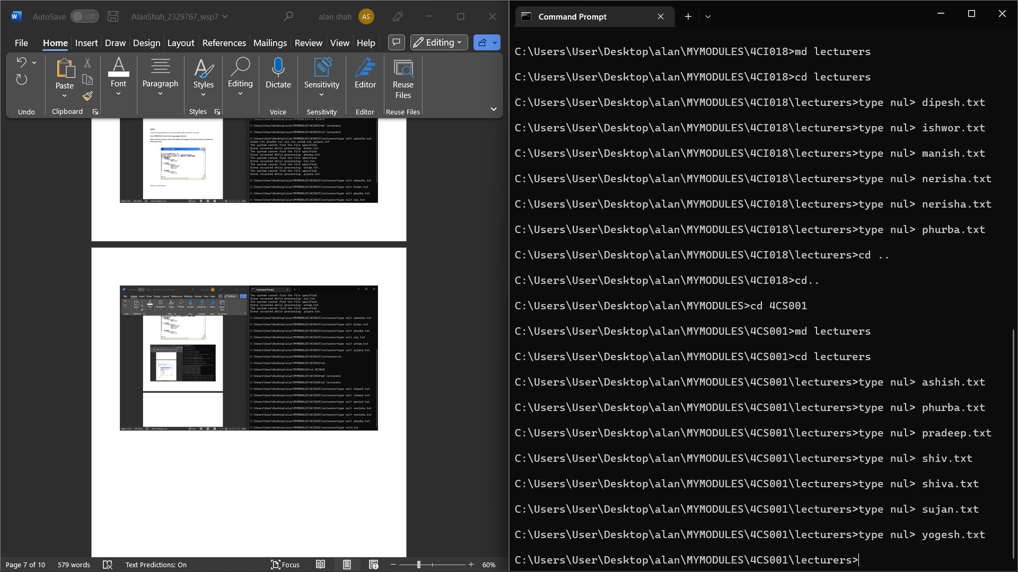

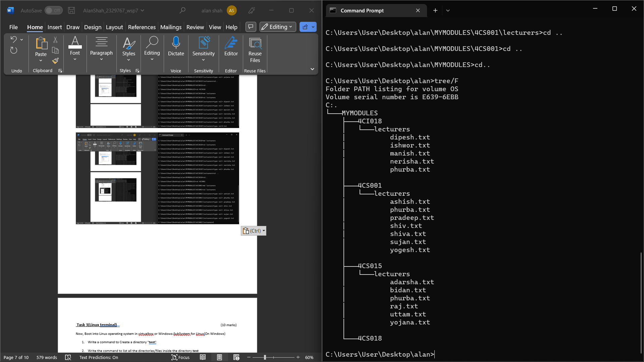

**Task 3(Linux terminal)** (10 marks)

Now, Boot into Linux operating system in virtualbox or Windows-SubSystem for LInux(On Windows)

1. Write a command to Create a directory "**test**"

Mkdir test

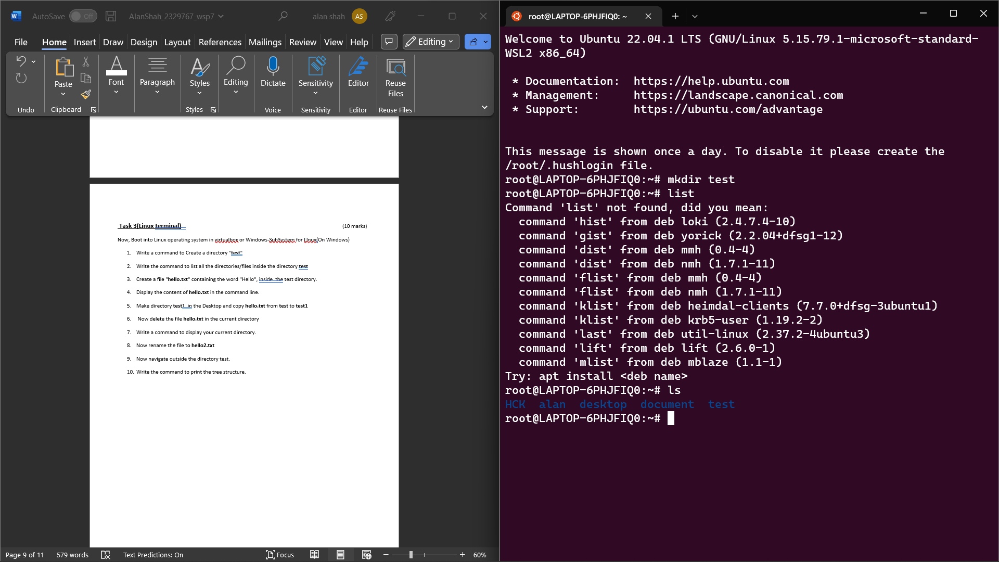

1. Write the command to list all the directories/files inside the directory **test**

**list**



1. Create a file "**hello.txt**" containing the word "Hello", inside the test directory.

Echo “hello” > test/hello.txt

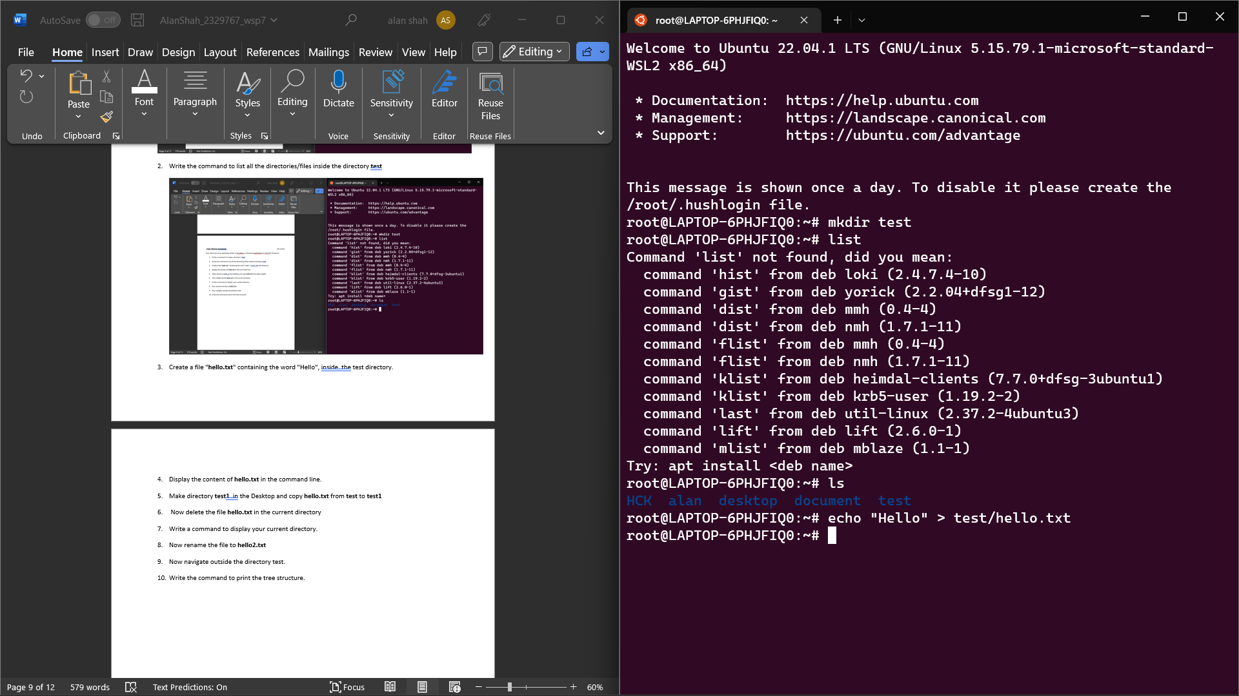

1. Display the content of **hello.txt** in the command line.

Cat test/hello.txt

=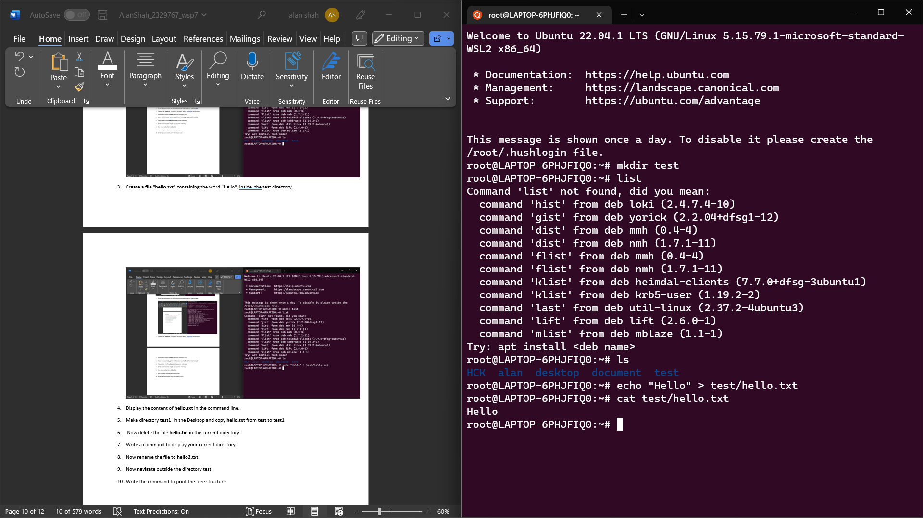

1. Make directory **test1** in the Desktop and copy **hello.txt** from **test** to **test1**

**Mkdir test**

**Cp test/hello.txt test1/hello.txt**

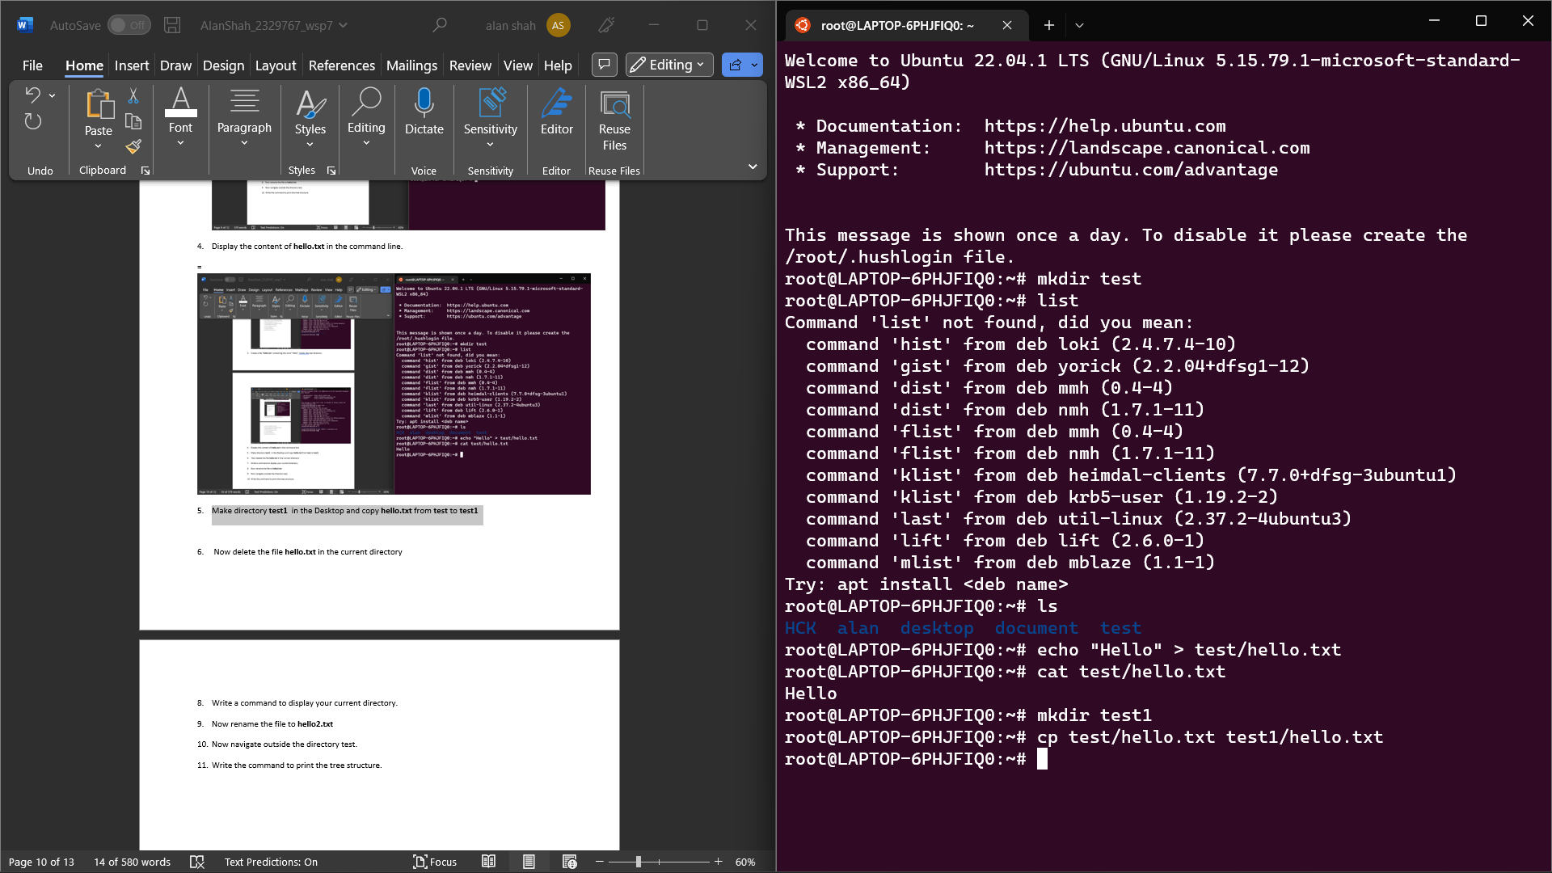

1. Now delete the file **hello.txt** in the current directory

Rm test/hello.txt

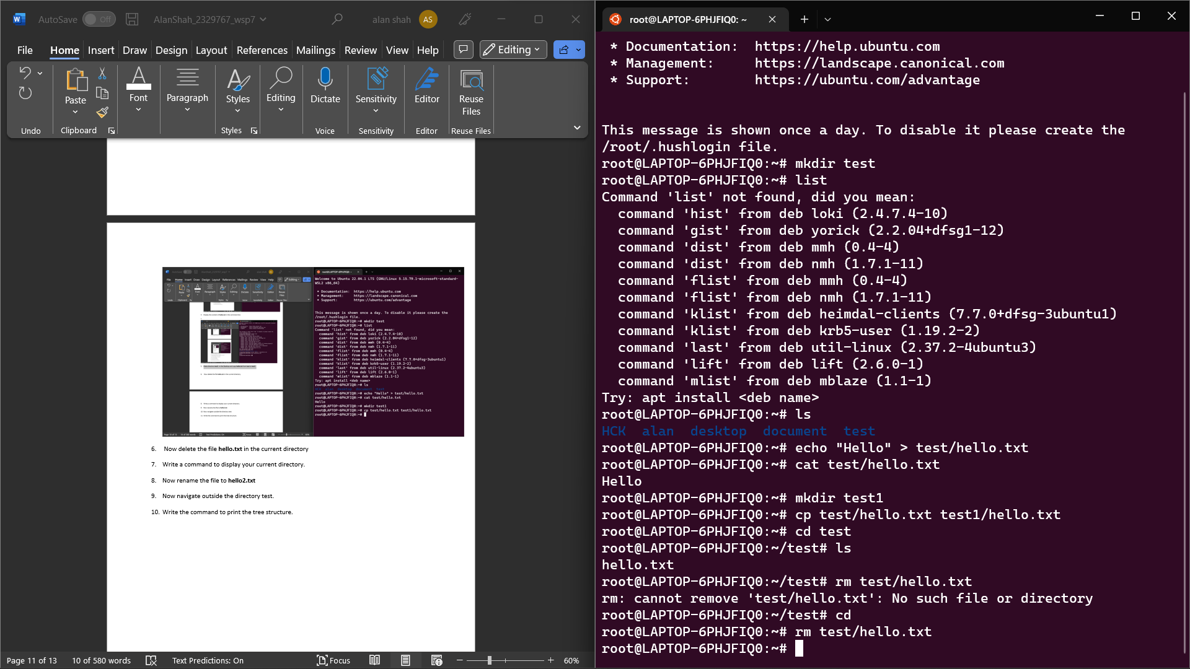

1. Write a command to display your current directory.

pwd

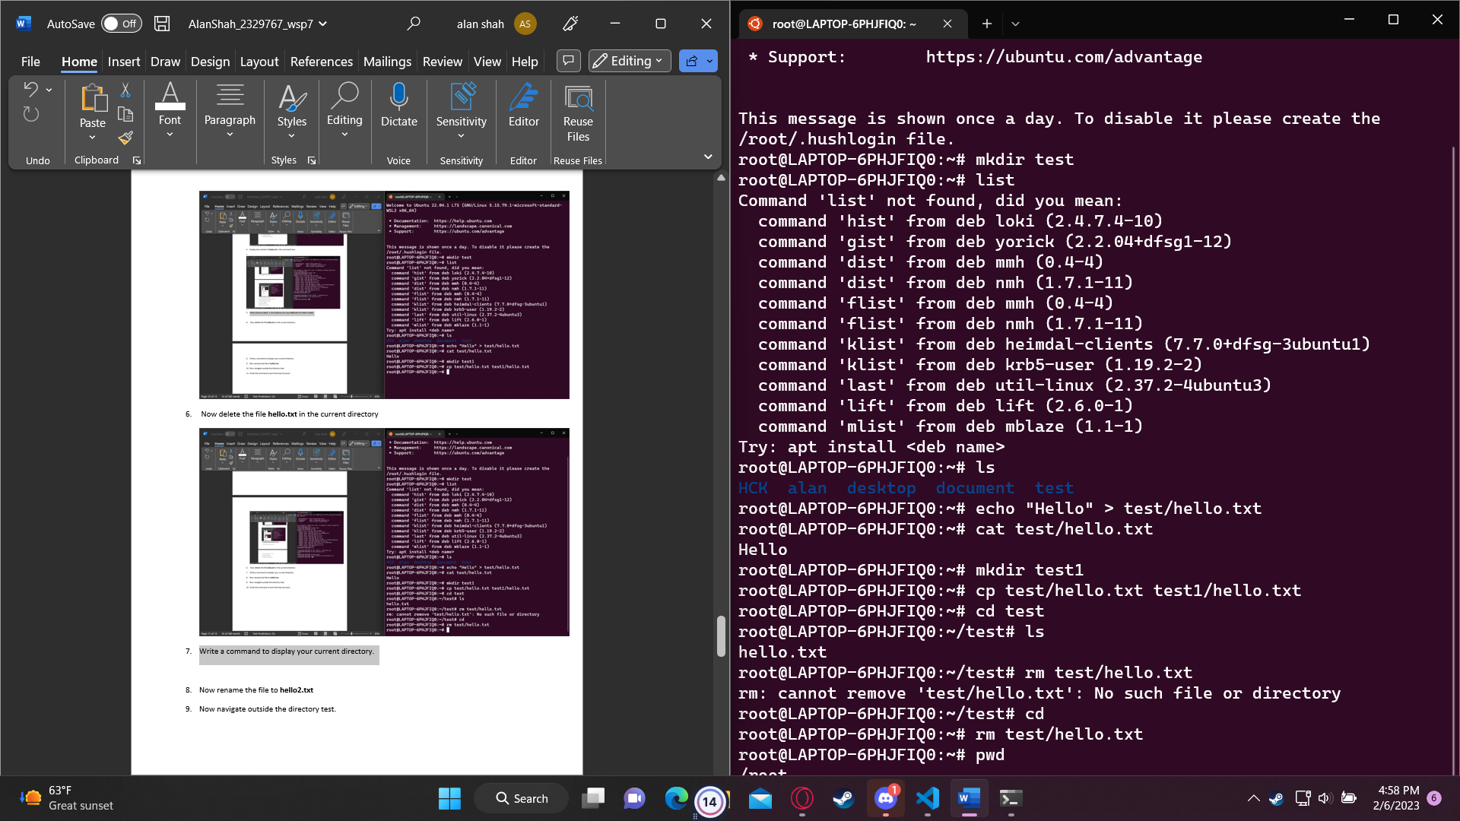

1. Now rename the file to **hello2.txt**

**Mn hello.txt hello2.txt**

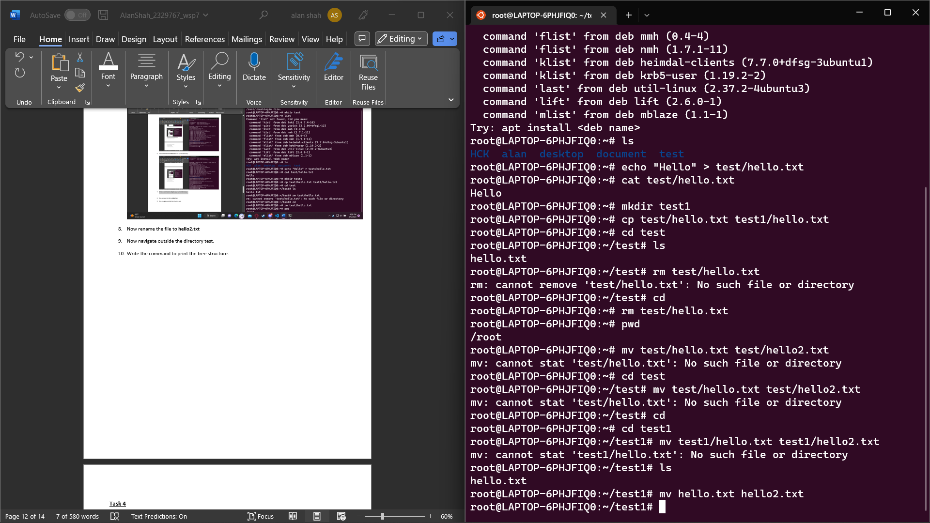

1. Now navigate outside the directory test.

Cd ..

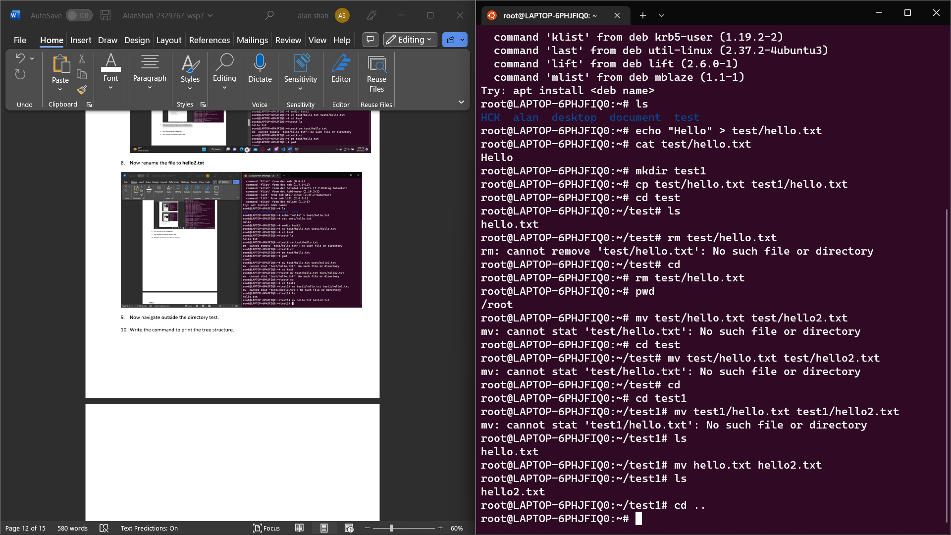

1. Write the command to print the tree structure.

tree

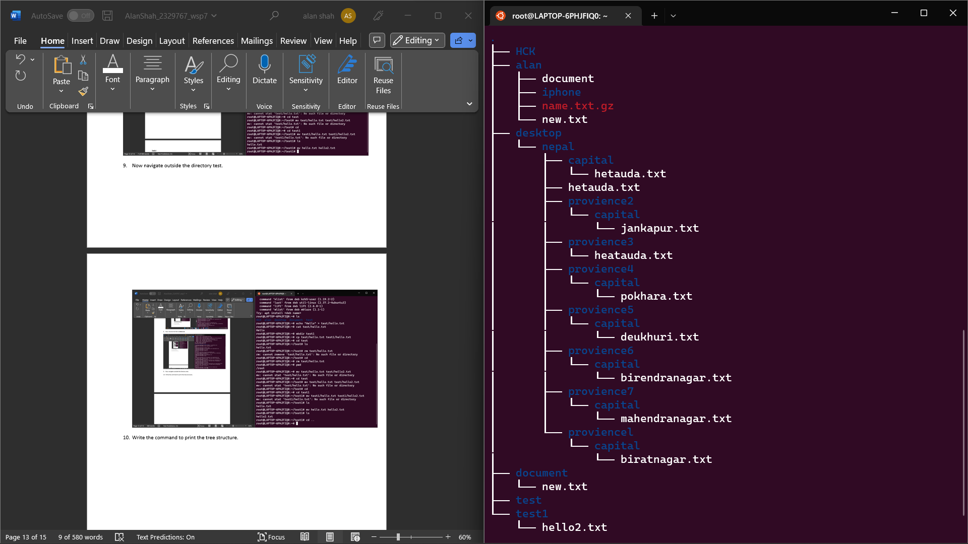

**Task 4**

Create the following directory structure (identical to the one that you created in Windows Command Prompt):

**Note: MYMODULES must be inside <your_name> directory.**

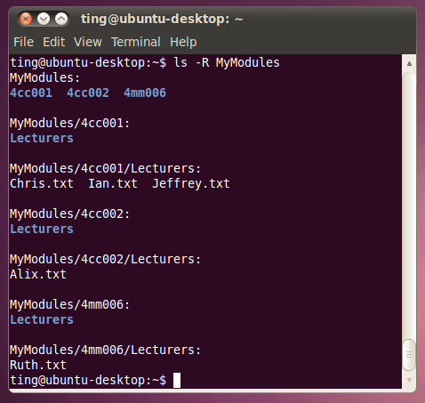

and insert it below (15 marks):

**code**

Mkdir alan

Cd alan

Mkdir MYMODULES

Cd MYMODULES

Mkdir 4CS001 4CI018 4CS015

Cd 4CS001

Mkdir lecturers

Cd lecturers

echo> ashish.txt

echo > phurba.txt

echo > pradeep.txt

echo > shiv.txt

echo > shiva.txt

echo > shujan.txt

echo > sunita.txt

echo >yogesh.txt

Cd 4CS001

Mkdir lecturers

Cd lecturers

echo > ashish.txt

echo > phurba.txt

echo > pradeep.txt

echo > shiv.txt

echo > shiva.txt

echo > shujan.txt

echo > sunita.txt

echo > yogesh.txt

Cd ..

Cd 4CI018

Mkdir lecturers

Cd lecturers

echo > dipesh.txt

echo > ishwor.txt

echo > manish.txt

echo > nerisha.txt

echo > phurba.txt

echo > raj.txt

Cd ..

Cd 4CS015

Mkdir lecturers

Cd lecturers

echo >adarsha.txt

echo > bidhan.txt

echo > phurba.txt

echo > raj.txt

echo > uttam.txt

echo > yojana.txt

Cd ..

Tree

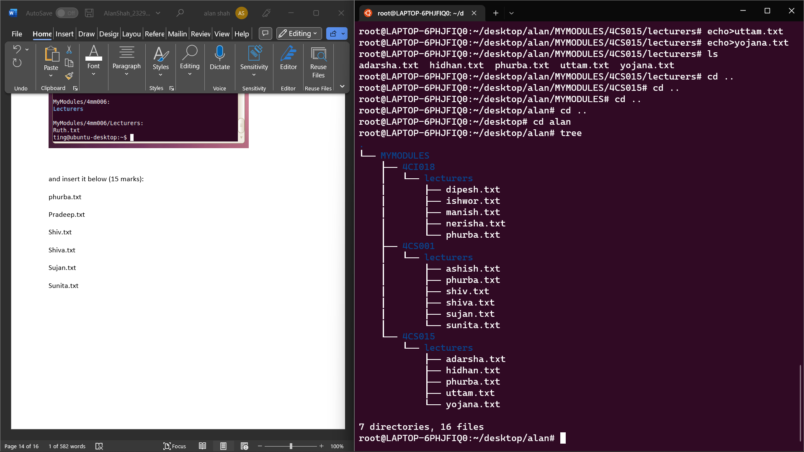

**Task 5**

**Batch file material (50 marks in total)**

Create a batch file (windows) **YourNumber.bat** from notepad (or your preferred text editor). Create this program on your home drive (or portable drive – USB) ready for execution.

The batch file should create a directory structure similar to the one created for the first section of this assignment but the directory entries should be provided from an input request from the batch file itself.

You should be able to create a root directory and directory structure and populate it if required. The batch file program will ask for names (**input directory names and file names**) to be used and have some form of **error checking** (empty – incorrect character, length, etc.) You can add other features such as being able to edit the new structure from within the batch file program (**find and change a directory name**).

Run batch file from windows prompt: YourNumber.bat <enter>

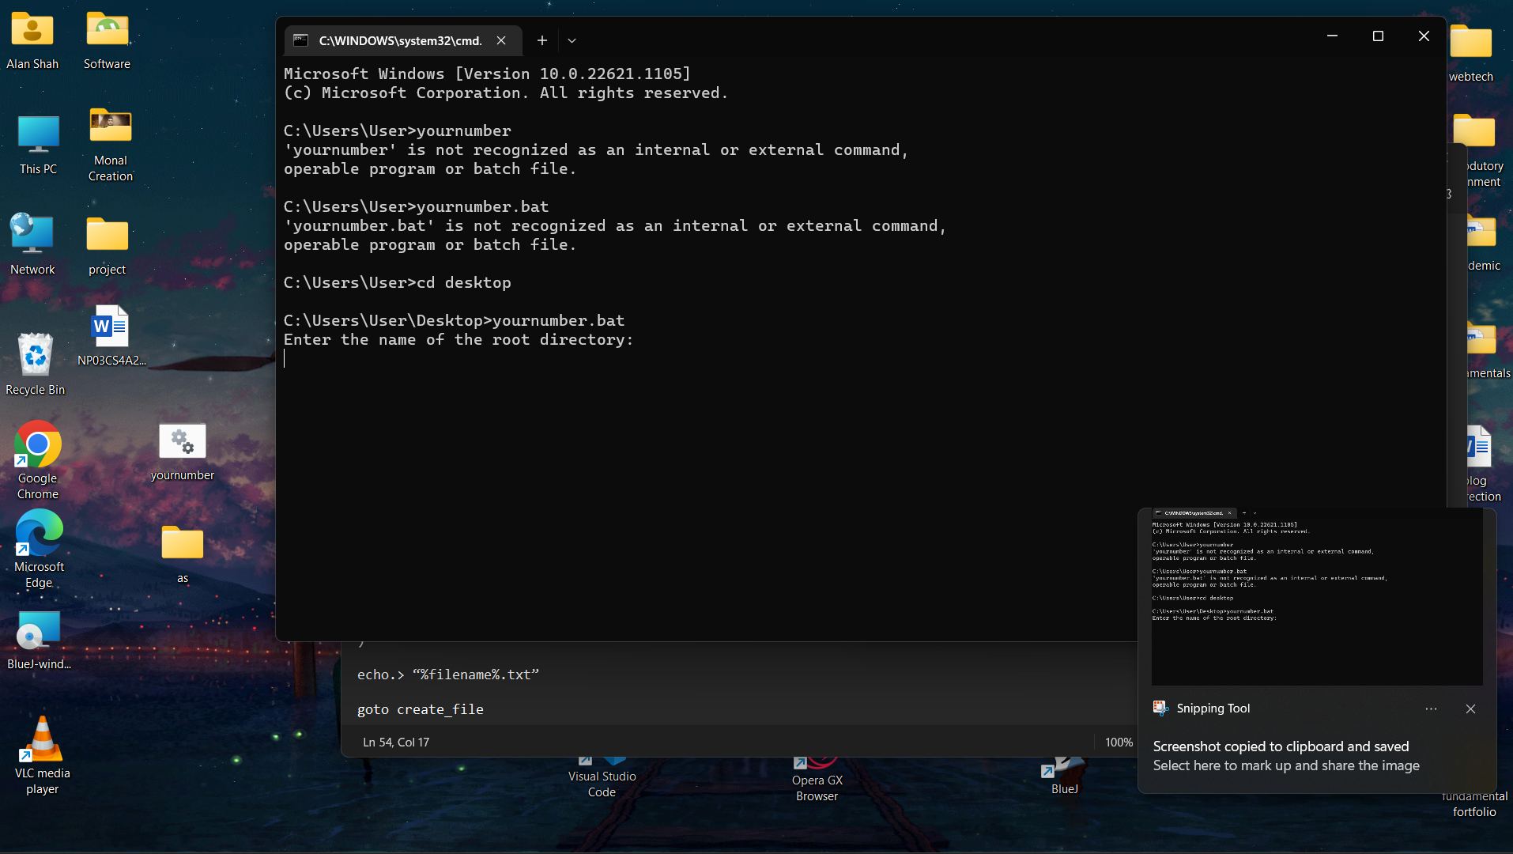

[Insert your picture(s) here] – Directory structure created / menu of batch file (inputs and output when batch file is executed) (10 marks)

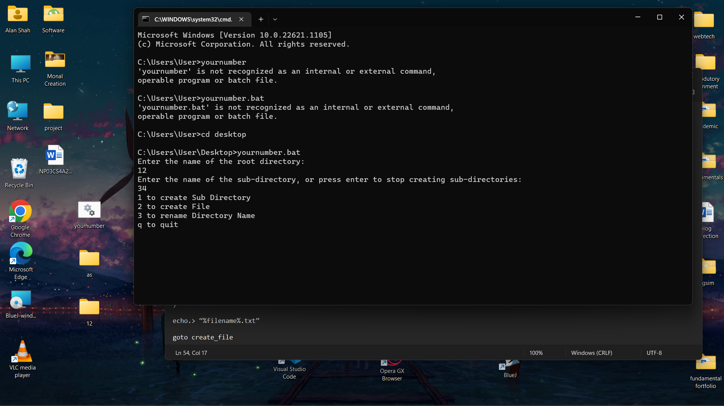

[Insert your text here] – batch file listing (script)(40 marks)

@echo off

goto createDirectory

:createStructure

goto createSubDirectory

:continueStructure1

echo 1 to create Sub Directory

echo 2 to create File

echo 3 to rename Directory Name

echo q to quit

set /p userChoice=

if "%userChoice%"=="1" goto createSubDirectory

if "%userChoice%"=="2" goto createFile

if "%userChoice%"=="3" goto renameDirectoryName

if "%userChoice%"=="q" exit /b

echo Error: Invalid option

pause

goto continueStructure1

exit /b

:createDirectory

echo Enter the name of the root directory:

set /p rootDirectory=

if "%rootDirectory%"=="" (

echo Error: Root directory name cannot be empty.

pause

goto createDirectory

)

if not exist "%rootDirectory%" mkdir "%rootDirectory%"

cd "%rootDirectory%"

goto createStructure

:createSubDirectory

echo Enter the name of the sub-directory, or press enter to stop creating sub-directories:

set /p subDirectory=

if not "%subDirectory%"=="" (

if not exist "%subDirectory%" mkdir "%subDirectory%"

cd "%subDirectory%"

SET subDirectory=

) else (

echo invalid name

pause

goto createSubDirectory

)

goto continueStructure1

:createFile

echo Enter the name of the file, or press enter to stop creating files:

set /p fileName=

if not "%fileName%"=="" (

echo Hello World! > "%fileName%.txt"

SET fileName=

) else (

echo fileName cannot be empty

pause

goto createFile

)

echo Directory structure and files created successfully.

pause

goto continueStructure1

:renameDirectoryName

echo Enter the directory path:

set /p dirPath=

echo Enter the new directory name:

set /p newName=

if "%dirPath%"=="" (

echo invalid path

pause

goto renameDirectoryName

)

if "%newName%"=="" (

echo invalid Name for directory

pause

goto renameDirectoryName

)

if exist "%dirPath%" (

ren "%dirPath%" "%newName%"

) else (

echo %dirPath% not found

)

echo Directory renamed successfully.

pause

goto continueStructure1